Jurassic World: Fallen Kingdom Chevy S10 Maintenance Truck

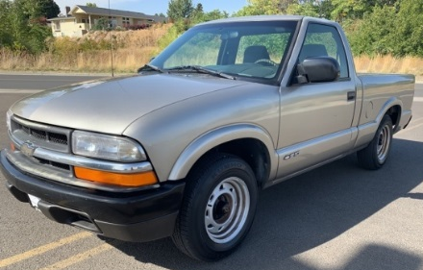
General Information:
- 1998-2004 Chevy S10 Pickup
  - Base model
  - Regular cab/short bed
  - Front bumper and fleetside rear bumper - black
1994-1997 Alternative Option with front and back end conversion (body is virtually identical with part swapping)
- 1994-1997 Chevy S10 Pickup
  - Base model
  - Regular cab/short bed
1998-2004 model parts required for front/rear end conversion of ’94-’07 models
Front End
  - Radiator support - GM 15009394
  - Grille (dark grey plastic) - GM 19180339
  - Grille retainers (11 needed) - GM 15002520
  - Headlights (driver/passenger) - GM 16526218
  - Headlight retaining clips (2 sets) - GM 15734237
  - Turn signals (without fog lamp) - GM 15098267 and 15098268
  - Low beam pigtails - Dorman Headlight Socket 85813
  - High beam pigtails - Dorman Headlight Socket 85812
  - Front bumper - GM 1002367
  - Front valence - GM 1092162
Rear End
  - Full Pickup fleetside bumper kit (black)(bumper, pads, brackets, lights, etc.) – Amazon, etc.

Forum threads about ’94-’97 to ’98-04 conversions:
https://www.s10forum.com/threads/94-97-to-98-light-conversion.460218/
https://www.s10forum.com/threads/how-to-convert-your-94-97-front-clip-to-98-s-10.208724/
Body:
Paint: Light Metallic Pewter - GM paint code WA382E
Interior:
- Charcoal black cloth seats
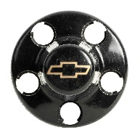
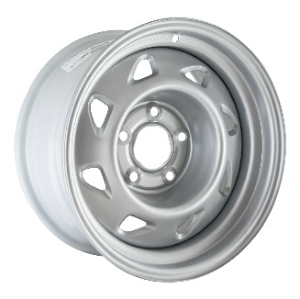
- Black dash, inner door panels and flooring.
Wheels:
- Base steel rims - part # 05030 (GM STL05030U20)
- Chevy black lug nut covers
- Tires – light duty truck/SUV tires (all black/no whitewalls)
Roll Bars
- Custom fabricated dual tube roll bars/headache rack

Decals:
- Door decals:
  - 2 x 11” Jurassic World emblem
  - 2 x “MAINTENANCE” - 3” tall letters with 0.5 “ separating each character
- Truck bed decals:
  - 2 x your vehicle number - 6.5” tall with 0.5” separating each character
- Use USAAF font for all lettering

