**V1.2 –combined docs, emailed to Adam**

[**http://www.jpmotorpool.com/reference/ml320/ml320_guide.html**](http://www.jpmotorpool.com/reference/ml320/ml320_guide.html)

**Photos are at:**

https://drive.google.com/open?id=1wlC3t9b8iJhYYpmtQFob74ahTKfbJ_9e

&

https://drive.google.com/open?id=1OOaOsEz13N_2FYlfv3lzAmiPWm7MkMa2

Photo names indicated in red

Quick Note:   
This section is now under construction and will soon include measurements of items—such as window guards—taken directly from the Stuttgart ML, interior information, and more. There’s a lot of info, so we’re doing this in stages. Keep an eye out!

General Information:   
Stuttgart 1  
• 1998–2001 ML320, W163 family   
• Mercedes-Benz revised and updated the ML320 in 2001 for the 2002 model year  
• All movie cars were pre-production prototypes

Movie Car Locations:  
• Europe: MIA ‘open rear’ model (approximate location is known) MIA

• Stuttgart, Germany: Benz Museum Stuttgart 2

• Vance, Alabama: Benz Visitor Center. No longer on display Vance

• Universal Studios, Florida: Islands of Adventure Orlando

• Universal Studios, California: Backlot Tour California

Quick Facts:

**Origin:**

Mercedes-Benz launched the first generation W163 series M-Class on February 19, 1997, in the United States for the 1998 model year, with sales beginning that September. [Wikipedia](https://en.wikipedia.org/wiki/Mercedes-Benz_M-Class)

**JP:TWL:**

In September 1996, before the vehicle was launched, Mercedes-Benz allowed the producers of the 1997 film The Lost World: Jurassic Park to make use of modified pre-production M-Class SUVs as a way to advertise the W163 when it was launched in 1997. As a result, a Mercedes-Benz advertisement appears before the film on original VHS copies of the film. Jeff Goldblum, the star of the film, received a complimentary ML320 from Mercedes-Benz as a result of the tie-in. [Wikipedia](https://en.wikipedia.org/wiki/Mercedes-Benz_M-Class)

**Redesign:**

Mercedes-Benz revised and updated the W163 in 2001 for the 2002 model year. Styling updates involved the fitment of new head- and tail-lamp lenses, front and rear bumpers, new alloy wheels on most variants, the relocation of the side turn signals from the fenders to the side-view mirrors, and various interior trim changes. [Wikipedia](https://en.wikipedia.org/wiki/Mercedes-Benz_M-Class),

**Additional Notes:**In October 1998, the ML went from a 50/50 torque split (front/rear) to a 48/52.

**LIGHTING**

Door/Side Mirror Lights:  
Source: MBUSI, Stuttgart Germany  
Lightswitches Hella1 Hella2 Hella3

• Hella Comet 500   
• Rock guard (movie only) is expanded sheet aluminum. 🡨 Link / anchor to St150 photo? Same shot.

• When purchasing, make sure the lens design matches. There ae a few variations out there.

In-Bumper Lights:  
Source: MBUSI, Stuttgart Germany

PIAA1 PIAA2

• PIAA 910 Ion

• Upright Mount Model  
• Modern 910 version lacks amber ‘Ion’ lens   
• Lights in bumper on Stuttgart car have their housing side screws and (possibly) the retaining post removed

• Appear to be mounted sideways and are painted matte black

Roof Lights:  
Source: Benz Visitor Center Car, Vance, Alabama GoLight GoLight2

GoLight RadioRay Portable Searchlight

The finalists are:

• Model #7900 and #7901 with wireless remote and magnetic mount   
• Model #5149 with wired remote and permeant mount

• Both models are identical in shape and size  
• #7900 also had an optional permanent mount part available to convert its mount  
• As the permanent and magnetic shoe are cross compatible, the only non-replicable difference is the wire/wireless option  
• Patents for both models were applied for at the same time, so both would have been in use in the mid 1990s  
• A tech at GoLight indicated that the inside and outside have changed since the 1990s  
• The #7900 remained unchanged externally at least through 2005  
• Light was repainted black: Light bezel and screws are now non-gloss and match the rest of the unit   
• Rock guard is expanded sheet aluminum epoxied/puttied into place

**Adam:** Suggest you remove this photo.

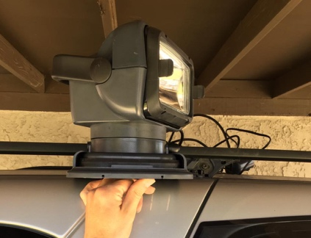

**Tires:**

**Dunlop Radial Mud Rover:**   
• LT265 / 75R16 Tires

**Body Accessories:**

Warn Warn2

**Winch:**   
• Warn M5000  
• Wired remote found in glovebox of the Stuttgart, Germany car

**On-Dash GPS:** GPS Citizen

• Mixed item prop   
• Built by Jerry Moss, this is an amalgamation of several familiar designs to purposely not be a direct off-the-shelf item. A close friend of Jerry, who worked with him on JP: TLW, said of this prop, “he was good at stumping people.”   
• GPS LCD is a Citizen M329 LCD Color Video Monitor

**Microphone:** NM1 NM2  
Full resolution photos below. Let me know if these don’t save correctly

• Motorola NMN6196A VISAR Radio Remote Speaker Mic  
• Reported to fit the following:

• H05KDD9AA4DN – VISAR, 16 Channel, VHF, no keypad

• H05KDH9AA7DN – VISAR, 16 Channel, VHF, keypad

• H05RDD9AA4DN – VISAR, 16 Channel, UHF Range 1, no keypad

• H05RDH9AA7DN – VISAR, 16 Channel, UHF Range 1, keypad

• H05SDD9AA4DN – VISAR, 16 Channel, UHF Range 2, no keypad• • H05SDH9AA7DN – VISAR, 16 Channel, UHF Range 2, keypad

• H05UCD6AA4DN – VISAR, 16 Channel, 800 MHz, no keypad

• H05UCH6AA7DN – VISAR, 16 Channel, 800 MHz, keypad

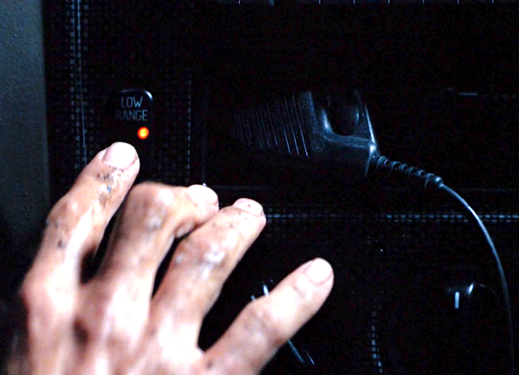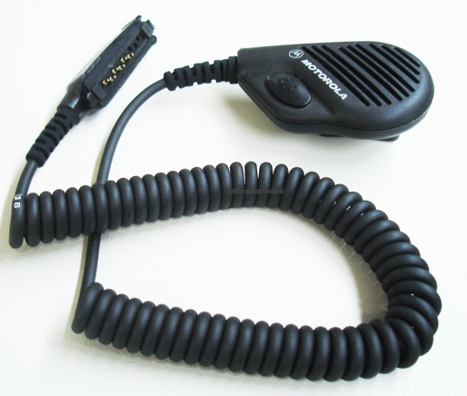

**Character Accessories:**  
Are there items you want identified or added? Let us know! 🡨 Mailbox for this page?

Ian

• Ian’s Subway Newspaper: The Sporting News, October 28, 1996 Sporting 1, Sporting 2

• Ian’s Satellite Phone: Mitsubishi ST150A and SZ300A Push-to-Talk Microphone ST1 ST2

Sarah

• Sarah’s Camera: Nikon F50/F50D (N50) F501 F502

• Sarah’s Bag: Willis & Geiger Outfitters Rucksack HBag1 HBag2

• Sarah’s Phone: Motorola Nextel iDen i370XL Mot1 Mot2

Nick

• Nick’s Camcorder: JVC GR-DVM1 JVC1 JVC2  
• Nick’s Motorpool Bag: Porta Brace Porta

• Exact model is currently unknown.   
 • There were a lot of variations made for specific brands and models of equipment.

• Nick’s Camera: Nikon F5 with a Nikon AF Nikkor 85mm f/1.8 D Portrait Lens Nikon1, Nikon2, Nikon3,

Eddie

• Eddie’s GPS: Tektronix WFM 90 / 91 series WFM1  
• Eddie’s GPS Bag: Lowepro Toploader Zoom AW LowPro1 LowPro2

• Eddie’s Binoculars:  Nikon 7x50 IF WP Compass NikonB1 NikonB2  
• Eddie’s Flashlight: Maxa Beam flashlight Maxa1 Maxa2

• Eddie’s Gun: Lindstradt Air Rifle [More Info](http://www.imfdb.org/wiki/Lost_World:_Jurassic_Park,_The#.22Lindstradt_Air_Rifle.22_.28Anschutz_1913_Super_Match.29) Lind1 Lind2

**Misc:**  
ML320 Data Sheet ML 320_data sheet.pdf  
ML320 Data Sheet 3  
Production Shot 1  
Production Shot 2